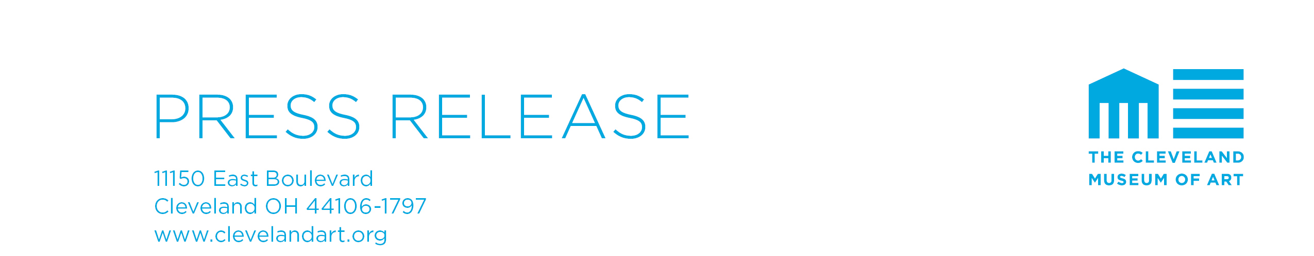

For more information and images, please contact:
Kelley Notaro Schreiber, 216-707-6898, knotaro@clevelandart.org

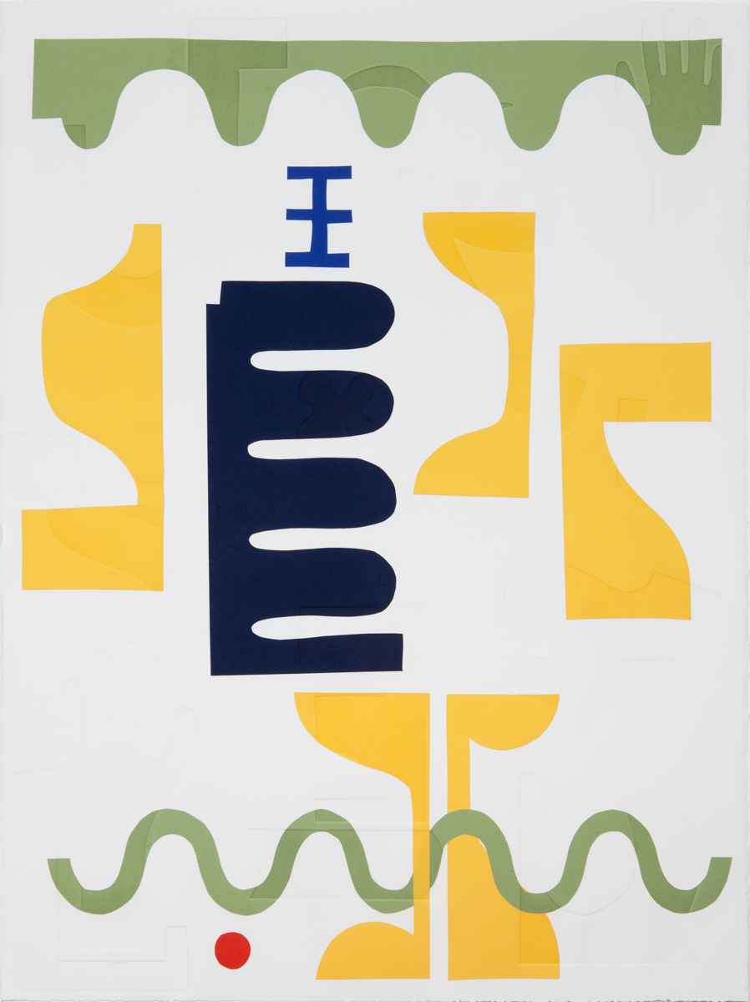

Calligraphy 25, 2018. Elizabeth Atterbury (American, b. 1982). Chine collé and embossing;
22.5 x 30 in., from a portfolio of 24 monotypes. Valued at $1,800, published and printed by Wingate Studio.
Donated by Wingate Studio.

The Print Club of Cleveland Hosts the 34th Annual Fine Print Fair
A benefit for the Cleveland Museum of Art’s Department of Prints and Drawings

Cleveland, OH (INSERT DATE)—The Print Club of Cleveland will hold its 34th Annual Fine Print Fair, Cleveland’s largest and most comprehensive exhibition of fine prints, beginning Thursday, October 11, with a ticketed opening night Benefit Preview Party. The fair continues Friday, October 12, from 10 a.m. to 6 p.m.; Saturday, October 13, from 10 a.m. to 5 p.m.; and Sunday, October 14, from 10 a.m. to 5 p.m. in the Ames Family Atrium at the Cleveland Museum of Art. Admission to the fair is free and open to the public. The Fine Print Fair benefits the museum’s Department of Prints and Drawings and is sponsored by the Print Club of Cleveland, a nonprofit Friends Group dedicated to enriching the museum’s print collection, with support from presenting sponsor Key Private Bank.

Fine art galleries from coast to coast and beyond will offer outstanding prints and drawings, from Old Masters to contemporary, for collectors at all levels. The exhibitors are ARMSTRONG FINE ART, Chicago (19th/20th-century French prints and drawings); JOEL BERGQUIST FINE ART, Stanford, CA (17th–20th-century European and American prints and drawings); C.G. BOERNER, New York City (16th–20th-century prints); CENTER STREET STUDIO, Milton Village, MA (print publisher); CONRAD R. GRAEBER FINE ART, Riderwood, MD (American, European, and Japanese prints and drawings); DAVIDSON GALLERIES, Seattle (15th–21st-century prints and works on paper); DOLAN/MAXWELL, Philadelphia, PA (Contemporary American and European prints and drawings); DURHAM PRESS, Durham, PA (print publisher); LUSENHOP FINE ART, Cleveland, OH (African American prints and drawings); MARY RYAN GALLERY, New York City (American and British prints and drawings, 1920–present); STONEY ROAD PRESS, Dublin, Ireland (print publisher) TAMARIND INSTITUTE, Albuquerque, NM (print publisher); THE VERNE COLLECTION, Cleveland, OH (Ukiyo-e and contemporary Japanese prints); and WINGATE STUDIO, Hinsdale, NH (print publisher).

The Fine Print Fair offers an opportunity to begin building a print collection, augment an existing collection, and learn about works on paper. The fair will include a variety of educational tours and activities, including printmaking demonstrations by local universities. The Intermuseum Conservation Association, the nation’s oldest regional fine art conservation center, will be on site to provide advice on the preservation and conservation of works on paper. As in previous years, the fair will include hourly drawings and the Print Club will hold a raffle for Elizabeth Atterbury’s Calligraphy 25 valued at $1,800 (pictured above). For additional information about the Fine Print Fair or the Print Club of Cleveland, please visit printclubcleveland.org, and keep an eye out for social updates via social platforms and the hashtag #fineprintfaircle.

The Print Club of Cleveland

Founded in 1919 by Ralph Thrall King, the Print Club of Cleveland is the oldest print club in the United States. Over the past 99 years, there has been unwavering dedication to the founder’s twin purposes of enhancing the Cleveland Museum of Art’s print collection by gifts, and of stimulating general interest in print collecting. The commitment and support of club members continues unabated; in fact, one-third of the collection of more than 20,000 prints came as gifts to the museum from the club or its members. The Print Club of Cleveland also reaches out to the community by sponsoring lectures and hosting the annual Fine Print Fair. The group continues to educate the public about printmaking and stimulate interest in the activity of print collecting.

About the Cleveland Museum of Art

The Cleveland Museum of Art is renowned for the quality and breadth of its collection, which includes almost 45,000 objects and spans 6,000 years of achievement in the arts. The museum is a significant international forum for exhibitions, scholarship, performing arts and art education. One of the top comprehensive art museums in the nation and free of charge to all, the Cleveland Museum of Art is located in the dynamic University Circle neighborhood.
The Cleveland Museum of Art is supported by a broad range of individuals, foundations and businesses in Cleveland and Northeast Ohio. The museum is generously funded by Cuyahoga County residents through Cuyahoga Arts and Culture. Additional support comes from the Ohio Arts Council, which helps fund the museum with state tax dollars to encourage economic growth, educational excellence and cultural enrichment for all Ohioans. For three consecutive years, the museum has been awarded a top four-star rating by Charity Navigator, the nation’s most-utilized independent evaluator of charities and nonprofits. For more information about the museum, its holdings, programs and events, call 888-CMA-0033 or visit www.ClevelandArt.org.

###

