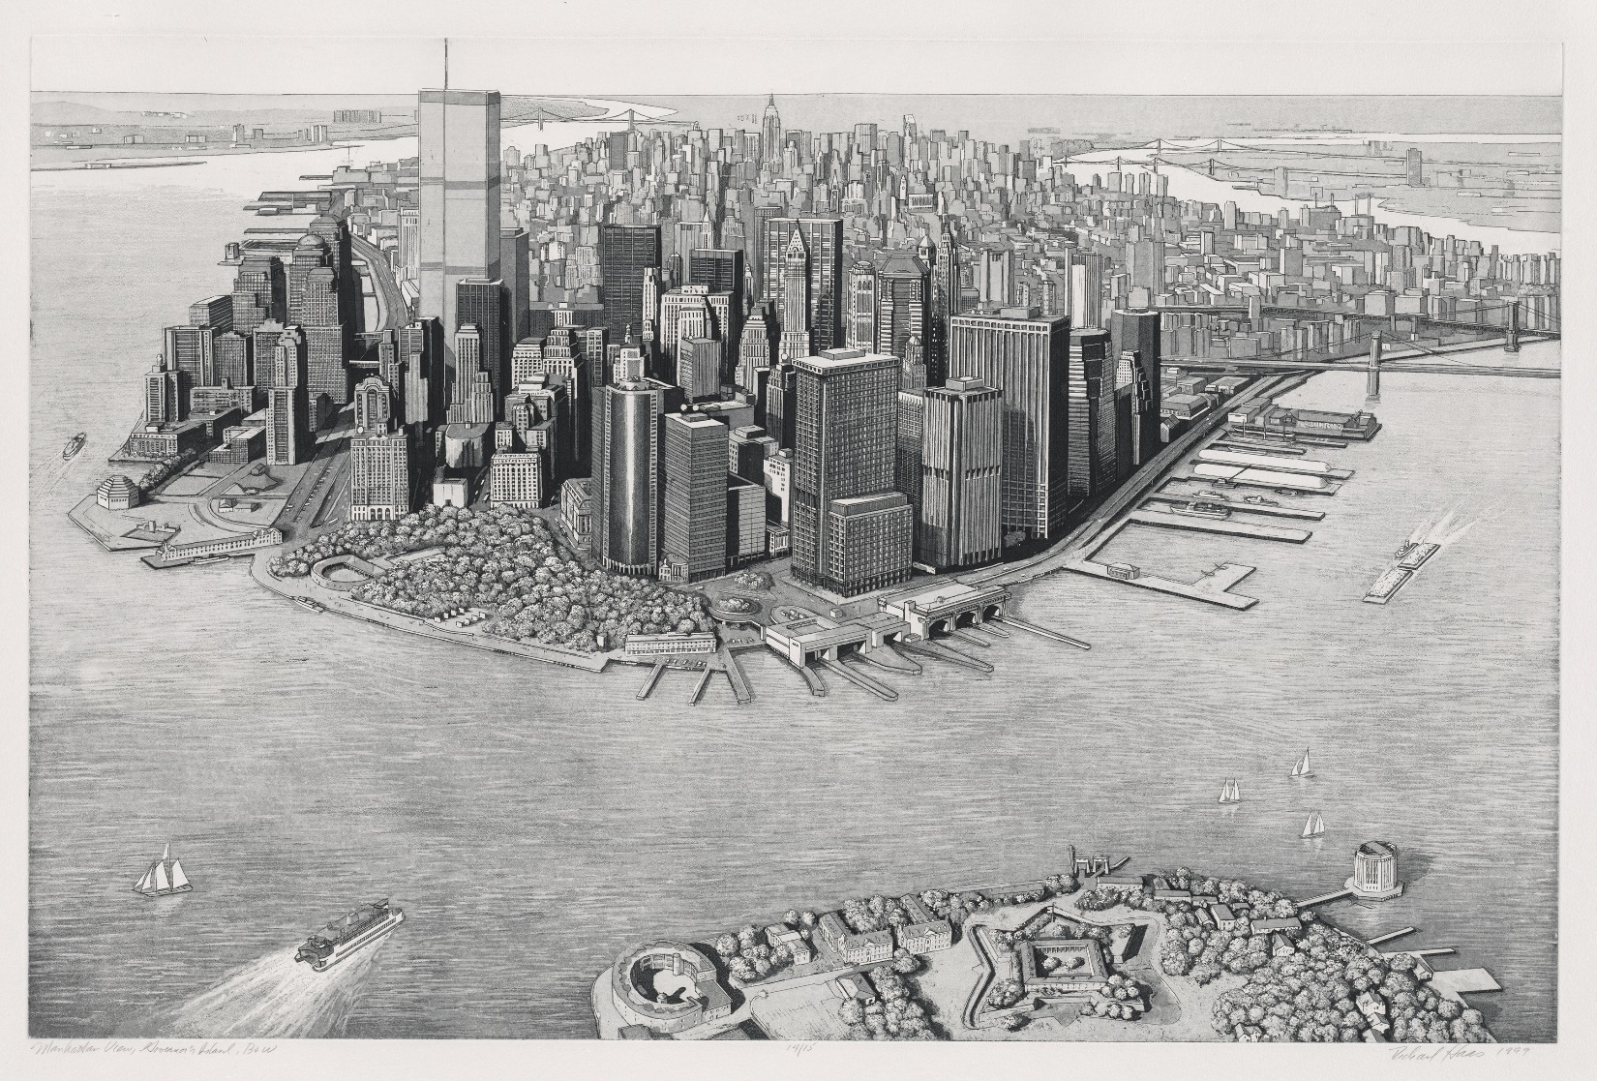
Raffle image: Richard Haas (American, born 1936). Manhattan View, Governor’s Island, 1999, etching and aquatint.
Valued at $3,500. Tickets $5 (six for $25). Donated by The Old Print Shop, New York.

The Print Club of Cleveland Celebrates the 31st Annual Fine Print Fair

The Fine Print Fair is a benefit for the Department of Prints at the Cleveland Museum of Art.

The Print Club of Cleveland celebrates the 31st Annual Fine Print Fair, admission to the fair is free to the public. The Fine Print Fair, Cleveland’s largest and most comprehensive exhibition of fine prints, begins Thursday, September 24, 2015, with an opening night ticketed benefit preview, “A Prints of a Party.” The fair continues Friday, September, 25, from 11 a.m. to 6 p.m., Saturday, September 26, from 10 a.m. to 5 p.m., and Sunday, September 27, from 10 a.m. to 5 p.m. in the Ames Family Atrium at the Cleveland Museum of Art (CMA). The Fine Print Fair benefits the Department of Prints at the Cleveland Museum of Art. It is sponsored by the Print Club of Cleveland, a nonprofit Friends Group dedicated to strengthening the museum’s print collection, with support from Key Private Bank.
Fine art galleries from coast to coast will offer five centuries of outstanding prints and drawings in a broad range of prices. The galleries are THE ANNEX GALLERIES, Santa Rosa, CA (19th/20th-century American prints); CENTER STREET STUDIO, Milton, MA (Print Publisher); DOLAN/MAXWELL, Philadelphia, PA (Contemporary American and European prints and drawings); PIA GALLO, New York, NY (Old Master and Modern Prints); CONRAD GRAEBER, Riderwood, MD (American, European, and Japanese prints and drawings); SUE OEHME, Steamboat Springs, CO (Print Publisher); THE OLD PRINT SHOP, New York, NY (American Prints 1900-1950); RYAN LEE, New York, NY (20th/21st-century American and British prints and drawings); CARL SOLWAY GALLERY, Cincinnati, OH (20th-century American and European prints and drawings); STEWART & STEWART, Bloomfield Hills, MI (Print Publisher); TANDEM PRESS, Madison, WI (Print Publisher); VANDEB EDITIONS, Long Island City, NY (Print publisher); THE VERNE COLLECTION, Cleveland, OH (Ukiyo-e and contemporary Japanese prints); MARK J. WEINBAUM, New York, NY (19th/20th-century fine art posters); ZANATTA EDITIONS, Shawnee, KS (Print Publisher).
The Fine Print Fair offers an opportunity to begin building a collection, augment an existing print collection, and learn about works on paper. A program of interest to both beginning and experienced print collectors will be held on Saturday, September 26, at 11 a.m. in the CMA’s recital hall. Dr. Jane Glaubinger, Curator of Prints at the Cleveland Museum of Art, will lecture on “Prints: The Multiple as Original.” This program, like the Fair, is free and open to the public. Dr. Glaubinger will also be available to answer questions at the Fine Print Fair all weekend.
In addition, local organizations will conduct interesting educational programs. During the weekend, the Morgan Conservatory, a papermaking conservatory, will demonstrate the art of papermaking. The Intermuseum Conservation Association, the nation’s oldest regional fine art conservation center, will be on-site both Saturday and Sunday to provide advice on the preservation and conservation of works of art on paper. For additional information about the Fine Print Fair or Print Club of Cleveland, please contact Melissa Grannetino mgrannetino@clevelandart.org or visit www.printclubcleveland.org.
The Print Club of Cleveland
Founded in 1919 by Ralph Thrall King, the Print Club of Cleveland is the oldest print club in the United States. Over the past 96 years, there has been unwavering dedication to the founders’ twin purposes of enhancing the Cleveland Museum of Art’s print collection by gifts and of stimulating general interest in print collecting. The commitment and support of club members continues unabated; in fact, one-third of the collection of more than 20,000 prints came as gifts to the museum from the club or its members. The Print Club of Cleveland also reaches out to the community by sponsoring lectures and hosting the annual Fine Print Fair. The group continues to educate the public about printmaking and stimulate interest in the activity of print collecting.

About the Cleveland Museum of Art
The Cleveland Museum of Art is renowned for the quality and breadth of its collection, which includes almost 45,000 objects and spans 6,000 years of achievement in the arts. The museum is a significant international forum for exhibitions, scholarship, performing arts and art education and recently completed an ambitious, multi-phase renovation and expansion project across its campus. One of the top comprehensive art museums in the nation and free of charge to all, the Cleveland Museum of Art is located in the dynamic University Circle neighborhood.
The Cleveland Museum of Art is supported by a broad range of individuals, foundations and businesses in Cleveland and Northeast Ohio. The museum is generously funded by Cuyahoga County residents through Cuyahoga Arts and Culture. Additional support comes from the Ohio Arts Council, which helps fund the museum with state tax dollars to encourage economic growth, educational excellence and cultural enrichment for all Ohioans. In 2014, the museum was awarded a top four-star rating by Charity Navigator, the nation’s most-utilized independent evaluator of charities and nonprofits. For more information about the museum, its holdings, programs and events, call 888-CMA-0033 or visit www.ClevelandArt.org.

